|  |  |  |  |
| --- | --- | --- | --- |
| **Jenis pesawat sinar-X** | | **Status izin** | |
|  | Radiografi Umum |  | Baru |
|  | Radiografi Mobile |  | Perpanjangan |
|  | Pesawat Gigi |  | Kadaluarsa |
|  | Fluoroskopi Konvensional |  | No. Izin: |
|  | Fluoroskopi Intervensional |  |
|  | Mamografi |  |  |
|  | CT-Scan |  |  |
|  | Penunjang Terapi |  | Perubahan Izin |
|  | Mobile Station (radiografi dalam mobil) |  | No. Izin: |
|  | Mobile station (mamografi dalam mobil) |  |

1. **DATA PEMOHON IZIN**

|  |  |  |  |
| --- | --- | --- | --- |
| Nama pemohon | : |  | |
| Jabatan | : |  | |
| Nama badan hukum | : |  | |
| Alamat badan hukum | : |  | |
| Kabupaten/kotamadya | : |  | Kode pos: |
| Propinsi | : |  |  |
| Telepon/fax | : | / | Email: |

**Lokasi pemanfaatan (RS/ klinik / praktik dokter)**

|  |  |  |  |
| --- | --- | --- | --- |
| Nama RS/Klinik | : |  | |
| Alamat RS/Klinik | : |  | |
| Kabupaten/kotamadya | : |  | Kode pos: |
| Propinsi | : |  |  |
| Telepon/fax | : | / | Email: |

1. **DATA TEKNIS PESAWAT**

|  |  |  |  |  |  |
| --- | --- | --- | --- | --- | --- |
| **Pesawat sinar-X** | | | **Tabung sinar-X *(insert tube)*** | | |
| Merk | : |  | Merk | : |  |
| Tipe/model | : |  | Tipe/model | : |  |
| Nomor seri | : |  | Nomor seri | : |  |
| Kondisi maks | : | kV mAs | Tahun produksi/instalasi: / | | |
|  | | |  | | |
| **Pengadaan pesawat sinar-X** | | | Alamat Importir/Penghibah: | | |
| Importir | : |  |
| Nomor izin | : |  |
| Hibah dari | : |  |

1. **DATA RUANG RADIOLOGI**

|  |  |  |  |  |  |
| --- | --- | --- | --- | --- | --- |
| Nama ruangan | : |  | Ruang operator | | |
| Ukuran | : | m x m x m | Ukuran | : | m x m x m |
| Bahan dinding | : | Bata | Bahan dinding | : | Bata |
|  | Beton |  |  | Beton |
|  | Triplek |  |  | Triplek |
| Tebal dinding | : | cm + mm Pb | Tebal dinding | : | cm + mm Pb |
| Penggunaan ruang sekitar | | | | | |
| Kanan | : |  | Belakang | : |  |
| Kiri | : |  | Atas | : |  |
| Depan | : |  | Bawah | : |  |

1. **DATA RUANG PENYIMPANAN (hanya diisi KHUSUS untuk RADIOGRAFI MOBILE)**

|  |  |  |
| --- | --- | --- |
| Nama ruangan | : |  |
| Perisai radiasi mobile (**harus ada**) | | |
| Jumlah perisai | : | unit |
| Ukuran perisai | : | cm x cm x cm |
| Ukuran kaca Pb | : | cm x cm x cm, mm Pb |

1. **PERSONIL**

|  |  |  |  |
| --- | --- | --- | --- |
| Fungsi[1] | Nama | Tempat/tgl lahir | Pendidikan terakhir |
| PPR / Nomor SIB |  |  |  |
| Dokter spesialis radiologi |  |  |  |
| Fisika medis |  |  |  |
| Radiografer |  |  |  |
|  |  |  |  |
|  |  |  |  |

1. **PERLENGKAPAN PROTEKSI RADIASI**

|  |  |  |  |  |
| --- | --- | --- | --- | --- |
| Jenis pemantau radiasi | Jumlah (unit) |  | Jenis peralatan proteksi | Jumlah (unit) |
| 1. Film badge |  |  | 1. Apron |  |
| 1. TLD |  |  | b. Pelindung tiroid |  |
| 1. Pocket dosimeter[2] |  |  | c. Pelindung gonad |  |
|  |  |  | d. Kacamata Pb |  |
|  | |  | e. Sarung tangan |  |
|  |  |  | f. Tabir radiasi mobile |  |

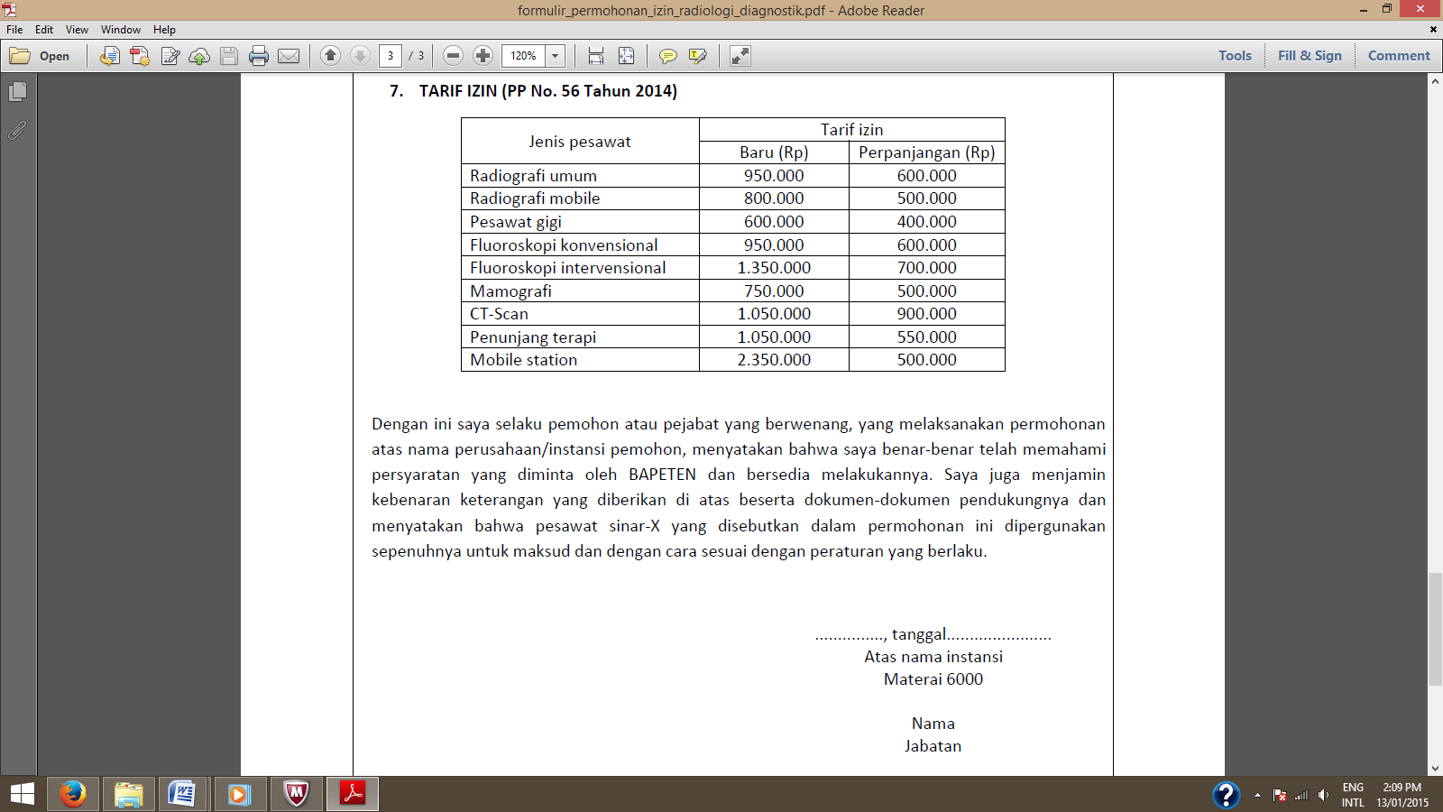

1. Cantumkan profesi pekerja radiasi, misalnya Dokter Spesialis radiologi, Dokter Bedah, Dokter Spesialis jantung, Dokter gigi, dll
2. Dosimeter saku minimal 2 (dua) buah